Date:29.05.2020

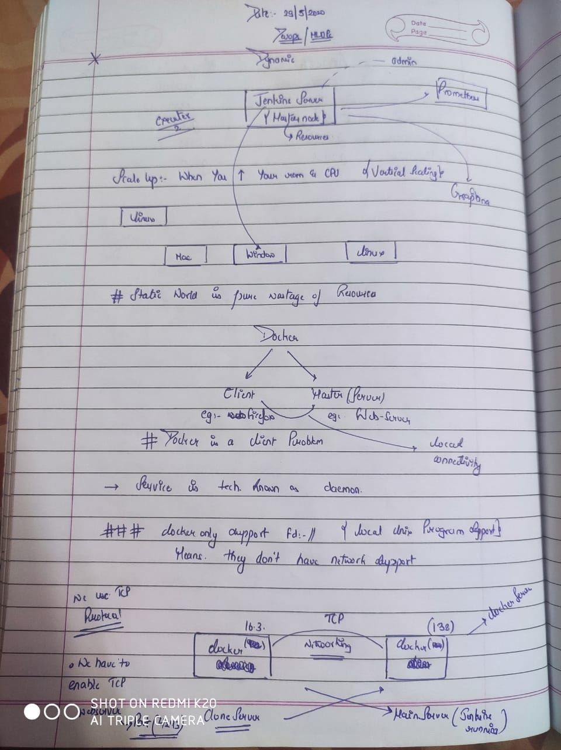

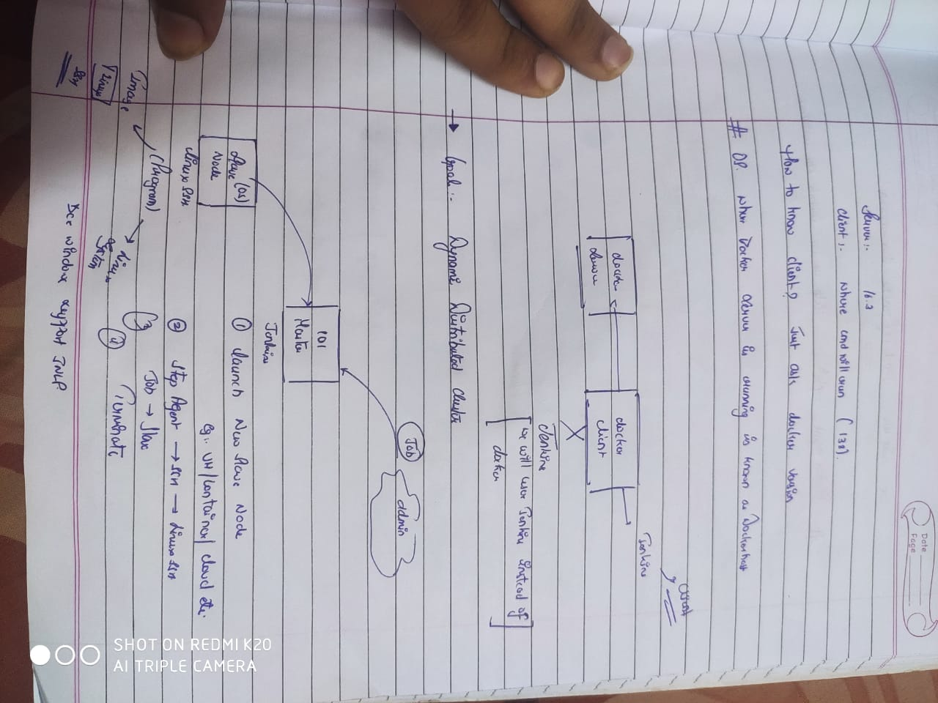

[root@localhost ~]# rpm -q docker-ce

docker-ce-18.09.0-3.el7.x86_64

[root@localhost ~]# docker --version

Docker version 19.03.8, build afacb8b

[root@localhost ~]# docker version

Client: Docker Engine - Community

Version: 19.03.8

API version: 1.39 (downgraded from 1.40)

Go version: go1.12.17

Git commit: afacb8b

Built: Wed Mar 11 01:27:04 2020

OS/Arch: linux/amd64

Experimental: false

Server: Docker Engine - Community

Engine:

Version: 18.09.0

API version: 1.39 (minimum version 1.12)

Go version: go1.10.4

Git commit: 4d60db4

Built: Wed Nov 7 00:19:08 2018

OS/Arch: linux/amd64

Experimental: true

Client-system

[root@localhost ~]# systemctl status docker

● docker.service - Docker Application Container Engine

Loaded: loaded (/usr/lib/systemd/system/docker.service; enabled; vendor preset: disabled)

Active: active (running) since Sun 2020-05-31 03:33:42 IST; 15s ago

Docs: https://docs.docker.com

Main PID: 18436 (dockerd)

Tasks: 8

Memory: 56.5M

CGroup: /system.slice/docker.service

└─18436 /usr/bin/dockerd -H fd://

May 31 03:33:39 localhost.localdomain dockerd[18436]: time="2020-05-31T03:33:39.559109363+05:30" level=info msg="Graph migration to content-addressability took 0.00 seconds"

May 31 03:33:39 localhost.localdomain dockerd[18436]: time="2020-05-31T03:33:39.562086288+05:30" level=warning msg="Your kernel does not support cgroup blkio weight"

May 31 03:33:39 localhost.localdomain dockerd[18436]: time="2020-05-31T03:33:39.562214316+05:30" level=warning msg="Your kernel does not support cgroup blkio weight_device"

May 31 03:33:39 localhost.localdomain dockerd[18436]: time="2020-05-31T03:33:39.570445106+05:30" level=info msg="Loading containers: start."

May 31 03:33:41 localhost.localdomain dockerd[18436]: time="2020-05-31T03:33:41.248888815+05:30" level=info msg="Default bridge (docker0) is assigned with an IP address 172.17.0.0/16. Daemon >

May 31 03:33:41 localhost.localdomain dockerd[18436]: time="2020-05-31T03:33:41.797912825+05:30" level=info msg="Loading containers: done."

May 31 03:33:42 localhost.localdomain dockerd[18436]: time="2020-05-31T03:33:42.256900402+05:30" level=info msg="Docker daemon" commit=4c52b90 graphdriver(s)=overlay2 version=18.09.1

May 31 03:33:42 localhost.localdomain dockerd[18436]: time="2020-05-31T03:33:42.257133099+05:30" level=info msg="Daemon has completed initialization"

May 31 03:33:42 localhost.localdomain dockerd[18436]: time="2020-05-31T03:33:42.370572049+05:30" level=info msg="API listen on /var/run/docker.sock"

May 31 03:33:42 localhost.localdomain systemd[1]: Started Docker Application Container Engine.

[root@localhost ~]# vim /usr/lib/systemd/system/docker.service

[root@localhost ~]# ifconfig enp0s8

enp0s8: flags=4163<UP,BROADCAST,RUNNING,MULTICAST> mtu 1500

inet 192.168.43.138 netmask 255.255.255.0 broadcast 192.168.43.255

inet6 fe80::af60:d1f:c501:733b prefixlen 64 scopeid 0x20<link>

inet6 2405:205:1083:3b2f:4afe:22dc:d93b:f9b8 prefixlen 64 scopeid 0x0<global>

ether 08:00:27:2d:71:27 txqueuelen 1000 (Ethernet)

RX packets 73284 bytes 89584295 (85.4 MiB)

RX errors 0 dropped 0 overruns 0 frame 0

TX packets 31477 bytes 2961063 (2.8 MiB)

TX errors 0 dropped 0 overruns 0 carrier 0 collisions 0

[root@localhost ~]# vim /usr/lib/systemd/system/docker.service

[root@localhost ~]# systemctl daemn-reload

Unknown operation daemn-reload.

[root@localhost ~]# systemctl daemon-reload

[root@localhost ~]# systemctl restart docker

[root@localhost ~]# systemctl status docker

● docker.service - Docker Application Container Engine

Loaded: loaded (/usr/lib/systemd/system/docker.service; enabled; vendor preset: disabled)

Active: active (running) since Sun 2020-05-31 03:37:56 IST; 32s ago

Docs: https://docs.docker.com

Main PID: 18646 (dockerd)

Tasks: 8

Memory: 38.1M

CGroup: /system.slice/docker.service

└─18646 /usr/bin/dockerd -H fd:// -H tcp://0.0.0.0:4243

May 31 03:37:54 localhost.localdomain dockerd[18646]: time="2020-05-31T03:37:54.259220080+05:30" level=warning msg="Your kernel does not support cgroup blkio weight"

May 31 03:37:54 localhost.localdomain dockerd[18646]: time="2020-05-31T03:37:54.259281310+05:30" level=warning msg="Your kernel does not support cgroup blkio weight_device"

May 31 03:37:54 localhost.localdomain dockerd[18646]: time="2020-05-31T03:37:54.261903558+05:30" level=info msg="Loading containers: start."

May 31 03:37:55 localhost.localdomain dockerd[18646]: time="2020-05-31T03:37:55.562844609+05:30" level=info msg="Default bridge (docker0) is assigned with an IP address 172.17.0.0/16. Daemon >

May 31 03:37:56 localhost.localdomain dockerd[18646]: time="2020-05-31T03:37:56.060234327+05:30" level=info msg="Loading containers: done."

May 31 03:37:56 localhost.localdomain dockerd[18646]: time="2020-05-31T03:37:56.291077991+05:30" level=info msg="Docker daemon" commit=4c52b90 graphdriver(s)=overlay2 version=18.09.1

May 31 03:37:56 localhost.localdomain dockerd[18646]: time="2020-05-31T03:37:56.291200534+05:30" level=info msg="Daemon has completed initialization"

May 31 03:37:56 localhost.localdomain dockerd[18646]: time="2020-05-31T03:37:56.351042792+05:30" level=info msg="API listen on [::]:4243"

May 31 03:37:56 localhost.localdomain systemd[1]: Started Docker Application Container Engine.

May 31 03:37:56 localhost.localdomain dockerd[18646]: time="2020-05-31T03:37:56.367612546+05:30" level=info msg="API listen on /var/run/docker.sock"

[root@localhost ~]# ifconfig enp0s8

enp0s8: flags=4163<UP,BROADCAST,RUNNING,MULTICAST> mtu 1500

inet 192.168.43.138 netmask 255.255.255.0 broadcast 192.168.43.255

inet6 fe80::af60:d1f:c501:733b prefixlen 64 scopeid 0x20<link>

inet6 2405:205:1083:3b2f:4afe:22dc:d93b:f9b8 prefixlen 64 scopeid 0x0<global>

ether 08:00:27:2d:71:27 txqueuelen 1000 (Ethernet)

RX packets 73530 bytes 89603065 (85.4 MiB)

RX errors 0 dropped 0 overruns 0 frame 0

TX packets 31609 bytes 2987883 (2.8 MiB)

TX errors 0 dropped 0 overruns 0 carrier 0 collisions 0

[root@localhost ~]# docker version

Client: Docker Engine - Community

Version: 19.03.10

API version: 1.39

Go version: go1.13.10

Git commit: 9424aeaee9

Built: Thu May 28 22:18:06 2020

OS/Arch: linux/amd64

Experimental: false

Server: Docker Engine - Community

Engine:

Version: 18.09.1

API version: 1.39 (minimum version 1.12)

Go version: go1.10.6

Git commit: 4c52b90

Built: Wed Jan 9 19:06:30 2019

OS/Arch: linux/amd64

Experimental: false

[root@localhost ~]# docker ps

CONTAINER ID IMAGE COMMAND CREATED STATUS PORTS NAMES

[root@localhost ~]# systemctl status docker

● docker.service - Docker Application Container Engine

Loaded: loaded (/usr/lib/systemd/system/docker.service; enabled; vendor preset: disabled)

Active: active (running) since Sun 2020-05-31 03:37:56 IST; 2min 49s ago

Docs: https://docs.docker.com

Main PID: 18646 (dockerd)

Tasks: 8

Memory: 35.3M

CGroup: /system.slice/docker.service

└─18646 /usr/bin/dockerd -H fd:// -H tcp://0.0.0.0:4243

May 31 03:37:54 localhost.localdomain dockerd[18646]: time="2020-05-31T03:37:54.259220080+05:30" level=warning msg="Your kernel does not support cgroup blkio weight"

May 31 03:37:54 localhost.localdomain dockerd[18646]: time="2020-05-31T03:37:54.259281310+05:30" level=warning msg="Your kernel does not support cgroup blkio weight_device"

May 31 03:37:54 localhost.localdomain dockerd[18646]: time="2020-05-31T03:37:54.261903558+05:30" level=info msg="Loading containers: start."

May 31 03:37:55 localhost.localdomain dockerd[18646]: time="2020-05-31T03:37:55.562844609+05:30" level=info msg="Default bridge (docker0) is assigned with an IP address 172.17.0.0/16. Daemon >

May 31 03:37:56 localhost.localdomain dockerd[18646]: time="2020-05-31T03:37:56.060234327+05:30" level=info msg="Loading containers: done."

May 31 03:37:56 localhost.localdomain dockerd[18646]: time="2020-05-31T03:37:56.291077991+05:30" level=info msg="Docker daemon" commit=4c52b90 graphdriver(s)=overlay2 version=18.09.1

May 31 03:37:56 localhost.localdomain dockerd[18646]: time="2020-05-31T03:37:56.291200534+05:30" level=info msg="Daemon has completed initialization"

May 31 03:37:56 localhost.localdomain dockerd[18646]: time="2020-05-31T03:37:56.351042792+05:30" level=info msg="API listen on [::]:4243"

May 31 03:37:56 localhost.localdomain systemd[1]: Started Docker Application Container Engine.

May 31 03:37:56 localhost.localdomain dockerd[18646]: time="2020-05-31T03:37:56.367612546+05:30" level=info msg="API listen on /var/run/docker.sock"

[root@localhost ~]# systemctl stop docker

[root@localhost ~]# docker version

Client: Docker Engine - Community

Version: 19.03.10

API version: 1.40

Go version: go1.13.10

Git commit: 9424aeaee9

Built: Thu May 28 22:18:06 2020

OS/Arch: linux/amd64

Experimental: false

Cannot connect to the Docker daemon at unix:///var/run/docker.sock. Is the docker daemon running?

[root@localhost ~]# docker ps

Cannot connect to the Docker daemon at unix:///var/run/docker.sock. Is the docker daemon running?

[root@localhost ~]# docker ps -a

Cannot connect to the Docker daemon at unix:///var/run/docker.sock. Is the docker daemon running?

[root@localhost ~]#

[root@localhost ~]# DOCKER_HOST=192.168.43.138:4243

[root@localhost ~]# docker ps

Cannot connect to the Docker daemon at unix:///var/run/docker.sock. Is the docker daemon running?

Run docker ps

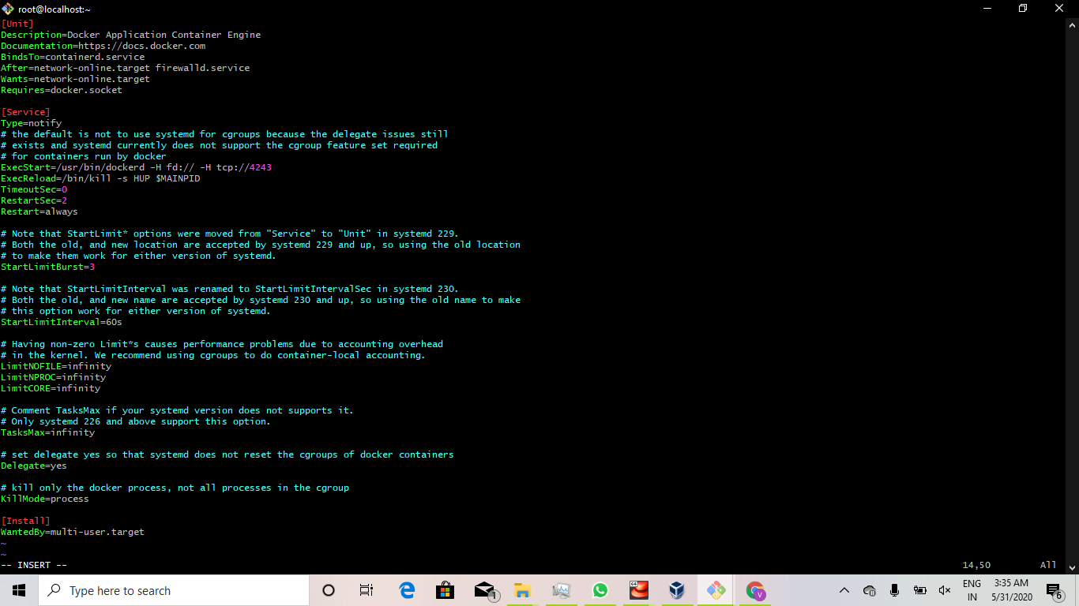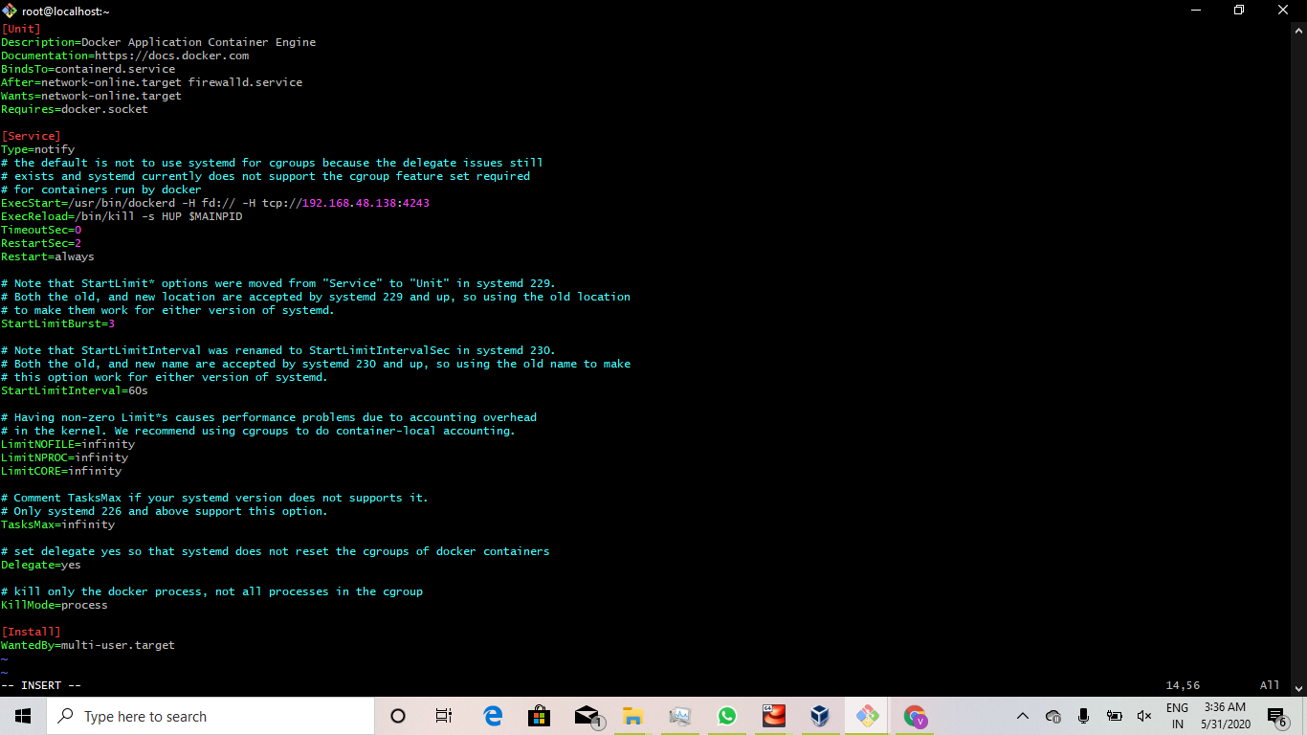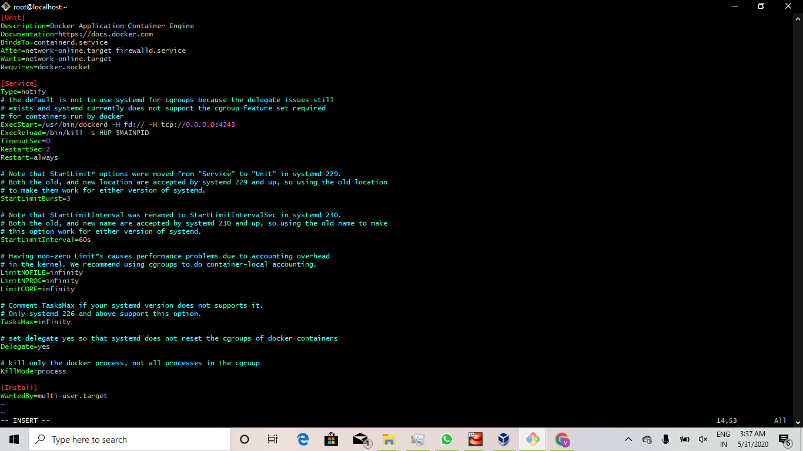

To remove all the running container docker rm -f $(docker ps -a -q)

Installed the plugins

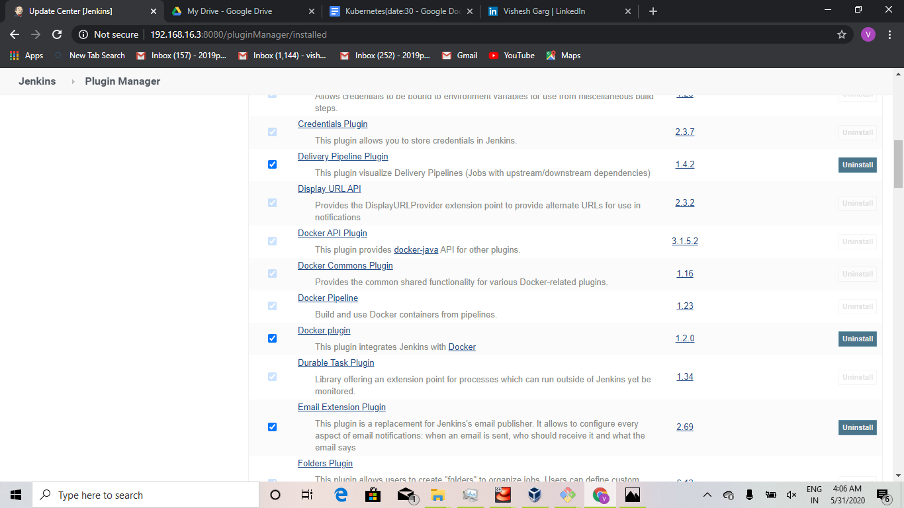

Delete all the nodes and only create master

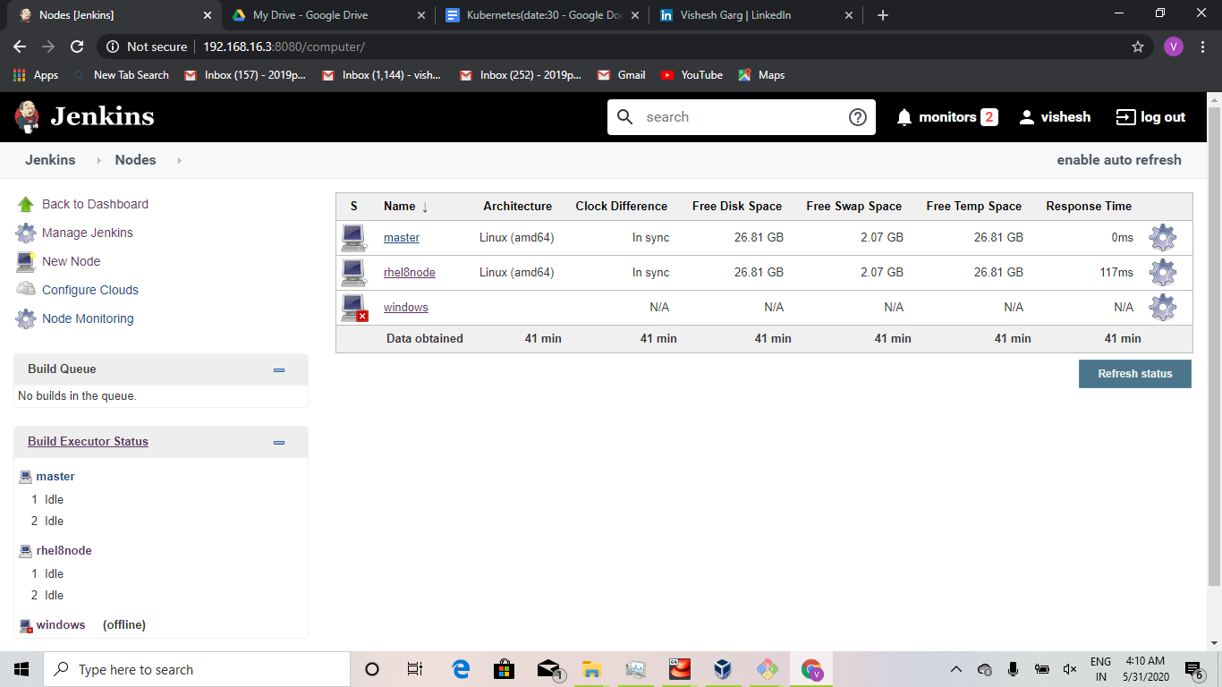

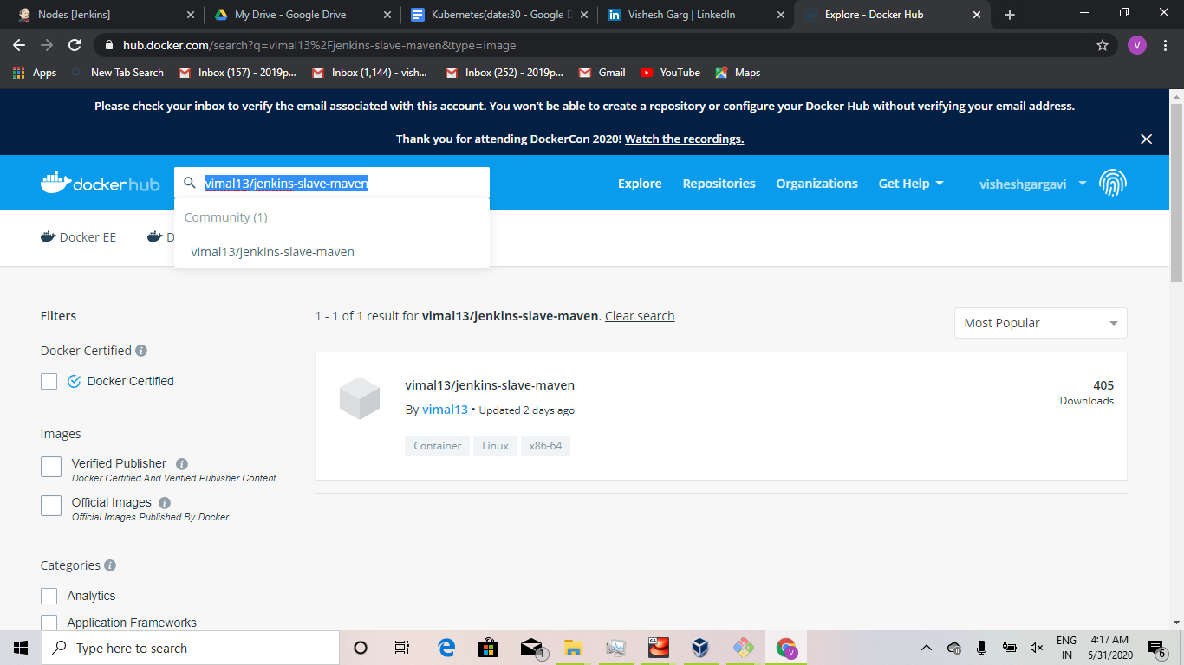

Username:jenkins

passwd:jenkins

Manage jenkins->manages nodes and cloud->Select configure cloud->select docker

